OYOU
OWN YOUR OWN UNIVERSE 501 C3
TAX RECEIPT

Own Your Own Universe (OYOU) is a 501 C3 non-profit organization based out of Texas. We transform lives by connecting the mind, body, and spirit through music and the creative arts.

Date of Donation:

Name/Address of Donor:

Total Donation Amount (Donation in cash, Kind, Gift Items):

Description of Donation (Goods, Items Donated):
Estimated Value:

This letter confirms that in accordance with tax laws, no goods or services were provided to the donor in return for the donation.

This document is mandatory for any federal income tax deduction for your contribution. Please retain it for your records.

The Own Your Own Your Own Universe (OYOU) sincerely thanks you for your generous contribution and your support. In case of any queries, you may contact us any of the details. We can also provide you our EIN# if you need it and other nonprofit materials if you need them.

Sincerely,

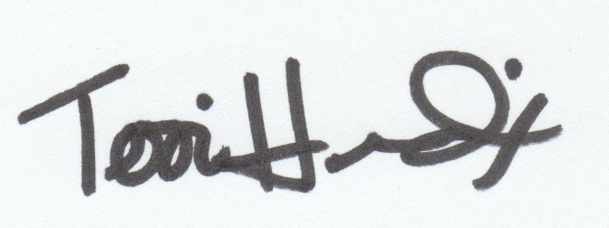

Terri Hendrix: Executive Director – Own Your Own Universe
Own Your Own Universe, 9191 FM 1979 Martindale, TX 78655

CONTACT
OWNYOUROWNUNIVERSE.ORG

